

**CATHOLIC UNIVERSITY OF EASTERN AFRICA**

**INFORMATION SYSTEM PROJECT FOR FINAL YEAR OF STUDY**

**IN**

**DIPLOMA IN INFORMATION TECHNOLOGY**

**BY**

**ARSHLEY AGATHA AOKO, ADM 1050911**

**AMBER VILLA HOTEL MANAGEMENT SYSTEM REPORT**

**AUGUST, 2024**

**DECLARATION**

I declare to the best of my knowledge that this project is my original work and has not been presented for a Diploma course in any other University. No part of this project may be reproduced without prior permission from the author.

**DEDICATION**

I wish to dedicate this entire project report to God. I thank God for the spirit of hard work, courage and determination instilled in me throughout my school days till today. I also honor and owe my dear parents for the happiness and appreciation for the guidance, protection and financial support they have been offering me.

**Supervisor name: _____________________________** **Signature: ____________________**

**ACKNOWLEDGEMENT**

First and for most, I would like to express my sincere thanks to the Almighty God for the gift of life, wisdom and understanding he has given to me, a reason for my existence. And to my family for providing me with love and support.

Madam Doreen whom I regard as my supervisor, I thank her for the expertise and intelligence he has displayed while supervising this project. I believe this good work will be a result of her good guidance and cooperation.

**Table of Contents**

**ABSTRACT** v

**TERMS AND ABBREVIATIONS** vii

LIST OF FIGURES AND TABLE viii

**1.0** **CHAPTER 1: INTRODUCTION** 1

**1.1** **Background** 1

**1.2** **Problem Statement** 1

**1.3** **Objective** 2

**1.4**  **Justification** 2

**1.5**  **Scope** 2

2.0 **CHAPTER 2: LITEREATURE REVIEW** 3

**2.1** **Introduction** 3

**2.2** **Previous Studies from Bandari Hospital** 3

**2.3** **Review of related systems** 4

**2.4** **Existing Patient Record Management Systems** 4

**2.5** **Emerging Trends** 4

**2.6** **Research Gap** 6

**2.7** **Chapter Summary** 6

**3.0** **CHAPTER 3: METHODOLOGY** 8

**3.1** **Data Collection** 8

**3.2** **Observation** 8

**3.3** **Interviews** 8

**3.4** **Questionnaires** 8

**3.5** **System Analysis and Design** 8

**4.0** **CHAPTER 4: PROJECT SCHEDULE** 16

**4.1** **Project Scheduling** 16

**5.0** **CHAPTER 5: SYSTEM DESIGN AND DEVELOPMENT** 18

**6.0** **SYSTEM TESTING AND IMPLEMENTATION** 23

Appendix: 26

**Abstract**

Abstract: Amber Villas Hotel Management System

The "Amber Villas Hotel Management System" proposes the development of a sophisticated information technology solution tailored for the unique requirements of Amber Villas Hotel. This project aims to streamline and automate various hotel management processes, offering an integrated platform to enhance operational efficiency, customer service, and decision-making.

The system will include modules for reservation management, room allocation, check-in/check-out procedures, billing and invoicing, inventory management, and employee administration. A user-friendly interface will be designed to ensure ease of use for both hotel staff and guests, fostering a seamless experience.

The "Amber Villas Hotel Management System" aspires to elevate the overall guest experience, optimize resource utilization, and provide valuable insights through data analytics. This project aligns with the hotel's commitment to innovation and excellence in hospitality management.

Key Features:

- Reservation Management

- Room Allocation and Check-in/Check-out Automation

- Billing and Invoicing

- Inventory Management

- Employee Administration

- Online Reservation Capability

- Enhanced Security Measures

The successful implementation of this project is anticipated to contribute significantly to Amber Villas Hotel's operational efficiency, customer satisfaction, and competitiveness in the hospitality industry.

**Terms and Abbreviations**

Terms and Abbreviations: Amber Villas Hotel Management System

1. *AVHMS*: Amber Villas Hotel Management System

2. *PMS*: Property Management System

3. *CRUD*: Create, Read, Update, Delete

4. *GUI*: Graphical User Interface

5. *API*: Application Programming Interface

6. *DBMS*: Database Management System

7. *UI*: User Interface

8. *UX*: User Experience

9. *CMS*: Content Management System

10. *SSL*: Secure Sockets Layer

11. *POS*: Point of Sale

12. *OTA*: Online Travel Agency

13. *RMS*: Reservation Management System

14. *OCR*: Optical Character Recognition

15. *ERP*: Enterprise Resource Planning

16. *BI*: Business Intelligence

17. *CRS*: Central Reservation System

18. *KPI*: Key Performance Indicator

19. *API*: Application Programming Interface

20. *SaaS*: Software as a Service

21. *GDPR*: General Data Protection Regulation

22. *SQL*: Structured Query Language

23. *CSV*: Comma-Separated Values

24. *HTTPS*: Hypertext Transfer Protocol Secure

25. *XML*: Extensible Markup Language

26 . *SSO*: Single Sign-On

27. *BI*: Business Intelligence

**CHAPTER 1: INTRODUCTION**

Amber Villas, a prestigious hotel nestled in [Diani], has been a beacon of luxury and hospitality in the hospitality industry. With its lush surroundings and exquisite services, Amber Villas has earned a reputation for providing an unparalleled guest experience. As the demands of the modern hotel industry evolve, Amber Villas recognizes the need for a cutting-edge solution to enhance operational efficiency, elevate guest services, and stay at the forefront of innovation.

**1.1 Background**

Amber Villas hotel is located in kwale along likoni ukunda road, Diani beach .

It’s a hotel that provides good security and transport facilities and a comfortable place of relaxation and enjoyment even a quite environment for reading and working.

The company product line includes food services,swimming,multipurpose activities like meetings and generally everything that a hotel facilitate.

This products find applications in educational, working,family and both commercial and residential needs.

**1.2 Problem Statement**

Amber Villas, a renowned hotel, currently faces challenges in its operational efficiency and guest services due to outdated and fragmented management processes. The existing manual systems for reservations, check-in/check-out procedures, inventory management, and overall administration result in inefficiencies, errors, and hinder the hotel's ability to provide a seamless guest experience.

Ideally, Customers should be able to view the available products and their prices and place an order anytime and anywhere. The Hotel should be able to keep track of all transactions, customers details and also give updates.Currently, The company has a website, but booking of the hotel is by visiting the place physically or via phone calls. The mode of payment is through M-PESA or paying cash and receipts are produced manually.The Problem is, there is a prolonged booking and payment processes that are exhausting and tiresome to the customer.

**1.3 Objective**

Objective• To develop a system for Amber villas hotel management system.Specific ObjectivesTo develop a Database module for Amber villas hotel management system.

To build an Administrator website interface for Amber villas hotel management system.

To develop a system for Amber villas hotel management system Front end users.

To develop a module for generating reports in Amber villas hotel management system.

**1.4 Justification**

■ The system will enable the customer to create an account.

The system will enable customers to view the product and their prices.

■ The administrator will be able to access and control all the users account, the modules and databases.

The finance controller will also be able to keep track of every payment and all the transactions as well.

**1.5 Scope**

* Database Module
* Administrator Module
* Customer Module
* Production Manager Module
* Air line catering Transport module
* Inventory Manager module
* Hotel Management Module
* Finance Controller Module
* Food Module
* Driver Module
* Booking Module
* Payment Module
* Search Module
* Reports Module
* Help Module
* Feedback Module
* About Us module

2.0 **CHAPTER 2: LITEREATURE REVIEW**

**2.1 Introduction**

In this section the research, location and analysis of the existing knowledge related to the subject of inquiry are explored and cited. It also sells at the relationship of the proposed research for purposes of good representation and critical review of the existing literature. As with other basic resources, professional management and organization of data are needed. The importance of efficient use of data for planning, predicting and other functions will become so great in a computerized organization that it will have a major effect on growth and survival of co-operations. In relation to the above argument, the presence of an automated data management system in Amber Villas efficiency, timely decisions and responses will be achieved.

**2.2 Previous Studies from Amber villa**

For the last few years, the hotel employees have been able to collect data from agents by providing them with a piece of paper with required fields to fill. Its routine for every hotel worker to collect data, this should be processed and stored completely. They avail the right information and knowledge to the right person and institution in the form at the right time and place. The information ranges from individual reports to rebalance to mortality rate in the right persons and institutions which include the counties that use the service, the service provider at local level, ministry of tourism. The company's employees and customer are straining to process lots of policy documents every day.

HISTORY OF RESEARCH PROJECT

These projects aim to improve the efficiency and effectiveness of managing customers information in booking settings. They involve the development and implementation of software systems that securely store and organize customers data, making it easier for professionals to access and utilize the information for customers care and research purposes. These systems have evolved over time, leveraging advancements in technology to enhance data accuracy, privacy, and interoperability. They have played a crucial role in streamlining tourism processes and improving customers outcomes.

**2.3 Review of related systems**

On a global scale, you can explore well-known hotel management systems like Booking.com. These systems are widely used in hotel organizations around the world and have undergone extensive research and development.

**2.4 Existing Hotel Record Management Systems**

I was able to analyze existing systems as discussed below. The current system was manual where data is written on different papers and transferred to the different departments, human errors were vulnerable since it was paper based and retrieval of files was time consuming as they had to manually locate files some of which were even 27 lost and thus finding such information was hard. Per the statistics carried 90% of the users were not contented with the system reason that it was not secure in terms of security and storage as it was prone to damages like loss of important information, worn out papers, outbreak of fire, The speed of recording and retrieval customers‟ information was average yet 10% were somehow okay with the system reason that the paper work can used for future reference. The users recommended that the proposed system should be user friendly, multipurpose enough to handle a number of users at a go, could generate feedback when request is submitted and use of passwords which could deny access to unauthorized users of system which ensured security.

**2.5 Emerging Trends**

• **Cloud-Based Solutions**: Cloud technology is becoming increasingly popular, offering hotels flexibility and scalability. Cloud-based HMS allow for real-time updates, remote access, and easier integration with other systems, which is crucial for managing multiple properties or locations.

• **Integrated Booking Engines**: Integration with online travel agencies (OTAs) and direct booking platforms is becoming standard. This helps hotels manage reservations more efficiently, avoid overbooking, and maximize revenue by reaching a broader audience.

• **Mobile Optimization**: Mobile-friendly systems and apps are essential for both staff and guests. Mobile check-ins, digital key cards, and mobile concierge services are becoming more common, enhancing the guest experience and operational efficiency. **Data Analytics and Reporting**: Advanced data analytics tools are being integrated into HMS to help hotels analyze guest preferences, booking trends, and financial performance. This enables more informed decision-making and targeted marketing strategies.**Artificial Intelligence and Automation**: AI is being used for various functions, including chatbots for customer service, automated revenue management, and predictive analytics to anticipate guest needs and optimize pricing.

**2.6 Research Gap**

Here are some potential research gaps that could be explored:

1. **Integration Challenges**: While many hotels use a range of software solutions, there is often a lack of seamless integration between different systems (e.g., property management systems, customer relationship management, revenue management). Research could focus on creating standardized protocols or developing middleware solutions to improve integration.
2. **Artificial Intelligence and Machine Learning**: Although AI and machine learning are increasingly used in HMS for tasks like pricing optimization and guest personalization, there is room for deeper research into how these technologies can be better utilized for predictive analytics, fraud detection, and dynamic service adjustments.
3. **Data Privacy and Security**: As HMS handle sensitive guest information, research is needed to address data privacy concerns and develop more robust security measures to protect against breaches and ensure compliance with global regulations such as GDPR.
4. **Guest Experience Personalization**: There is a gap in understanding how to effectively use guest data to personalize the experience without infringing on privacy. Research could explore ethical approaches and technological solutions for enhancing personalization while respecting guest preferences and privacy.
5. **Sustainability and Eco-Friendly Practices**: The integration of sustainability features into HMS is still in its infancy. Research could focus on how HMS can support eco-friendly practices, such as energy management, waste reduction, and sustainable sourcing, and measure their impact on operational efficiency and guest satisfaction.

**2.7 Chapter Summary**

This chapter provides a comprehensive overview of the research methodology, history of the research topic, review of related prototypes and systems, emerging trends, and research gap in management systems in Amber Villa.

The chapter begins by outlining the research methodology employed in the study. It discusses the approach, data collection methods, and analysis techniques used to gather and interpret the data. This section ensures the validity and reliability of the research findings.

Next, the chapter delves into the historical background of the research topic. It explores the evolution of Amber Villas management systems, highlighting key milestones and developments that have shaped the field. This historical context provides a foundation for understanding the current state of the research topic.

Following that, the chapter conducts a comprehensive review of related prototypes and systems in the field of patient information management. It examines existing solutions, their features, functionalities, and limitations. This review helps identify gaps and opportunities for innovation in Amber Villas management system.

Moreover, the chapter explores emerging trends in Amber Villas management systems. It discusses advancements in technology, such as artificial intelligence, machine learning, and interoperability standards, and their potential impact on improving healthcare delivery and patient outcomes.

**3.0 CHAPTER 3: METHODOLOGY**

This is a description of methods chosen to achieve the objectives of the proposed system. It will go on to describe the techniques of data collection that will be employed in the research study of the proposed systems. The methods that will be applied to achieve the specific objectives are namely: Literature review, Oral interviews, system analysis, system design, Data modeling and Black box testing. The tools that will be used to implement the system are MySQL, HTML.

**3.1 Data Collection**

I used the following methods during data collection: Observation, Interviewing and Questionnaires as our research methods. Through this I was able to collect raw data at hotel where existing reports on the current system were obtained. Verbal interview techniques were used to interview employees from the hospital.

**3.2 Observation**

I went to the hotel and observed their daily as regards their current system and they were manually recording the customer records as specified by the receptionists, attenders and cashier. A follow up was made to determine the time it took to carry out the hotel system management. observed the system’s weaknesses like it was vulnerable to errors.

**3.3 Interviews**

Interviews were conducted with the hotel supretendant and some potential employees to find out what difficulties they encountered with the existing system. These interviews were held to verify the information collected using the questionnaires since there was room to search for further information during the interview.

**3.4 Questionnaires**

The efficiencies and inefficiencies of the current system were reviewed by issuing questionnaires to the users of the system. This helped me to establish the requirements of the proposed system.

**3.5 System Analysis and Design**

During the system study phase, requirements were categorized into user requirements, system and hardware requirements.

**3.5.1 System Requirements**

After analyzing the data collected, I formulated a number of requirements namely user requirement, system hardware software attribute. These were grouped as user and systems requirements.

**3.5.2 User Requirements**

During data collection, I investigated and found out how the current system operates, not only that but also tried out which problems are faced and how best they can be settled. The users described some of the basic requirements of the system this includes Search for customers, register staff, Update, staff records, customer and view all types of reports.

**3.5.3 System Design**

After interpretation of the data, tables were drawn and process of data determined to guide the researcher of the implementation stage of the project. The tools, which were employed during this methodology stage, were mainly tables, Data Flow Diagrams (DFDs) and Entity Relationship Diagrams (ERDs). The design ensures that only allows authorized users to access the system’s information.

Figure 1: Logical Model

No

Yes

Log in

success

Process relevant records

Access appropriate user profile

Review login credentials

Commit changes to database

Data access and reports generations

Data access

Yes

Log into PIMS

success

Process relevant records

Access appropriate user profile

Review login credentials

Commit changes to database

Data access and reports generations

Data access

Figure 1: Logical Model

This figure shows the logical flow of events in the system, it caters for the time when the user logs in and signs out from the system.

**4.3.1 System Architecture**

This gives a high-level view of the new system with the main components of the system and the services they provide and how they communicate. The system is implemented using a three-tier architecture that comprises of user interface, process management and DBMS as illustrated below.

**Report generation**

Customers report

Account report

Database

Data control

Data

**Forms**

customers data

boards data

staff data

Account data

**Graphical user interface (GUI)**

User authentication

User registration

View information

Edit profiles

[*Figure 2: System Architecture*](https://d.docs.live.net/b63cbc9aaca1850f/Documents/CATHOLIC%20UNIVERSITY%20OF%20EASTERN%20AFRICA%20pr1.docx#_Toc172710038)

This chapter emphasizes the actual system implementation. The system was transformed from user requirement into a workable product. The purpose of system implementation was to make sure that the correct application is delivered to the end user. Besides that, this chapter also emphasizes on how the testing is done to confirm to meets the user requirement.

**4.3.2 User Requirements**

For effective use of the system, users must be fully involved and are given opportunities to participate as much as possible This rectifies numerous problems associated with change management, users getting accustomed to using new way of doing things as opposed to traditional system of the hotel management system. During data collection, the researcher investigated and found out how the current system operates, not only that but also tried out which problems are faced and how best they can be settled. The users described some of the basic requirements of the system as;

* Search for customers
* Register staff.
* Update, staff records, clients
* View all types of reports.
* Assign access rights and privileges to system users.

**4.3.3 Functional Requirements**

The following is the desired functionality of the new system.

* The system should accept have submissions in form of raw clients, staff, and service providence at the submitting point.
* The system should perform analysis of financial, accomodation, programmes available, and review.
* The system should authenticate the users of the system.
* The system should generation of reports on request.
* The system should only allow the administrator to delete records in the database.

Non-Functional Requirements

* The system should must verify and validate all user input and users must be notified in case of errors detected in the course of using the system.
* The system should allow room for expansion.
* A system should have a high performance and reliability level.

**4.3.4 Software Requirements**

* **Entity Relationship and their cardinality**
* **4.0 CHAPTER 4: PROJECT SCHEDULE**
* **4.1 Project Scheduling**

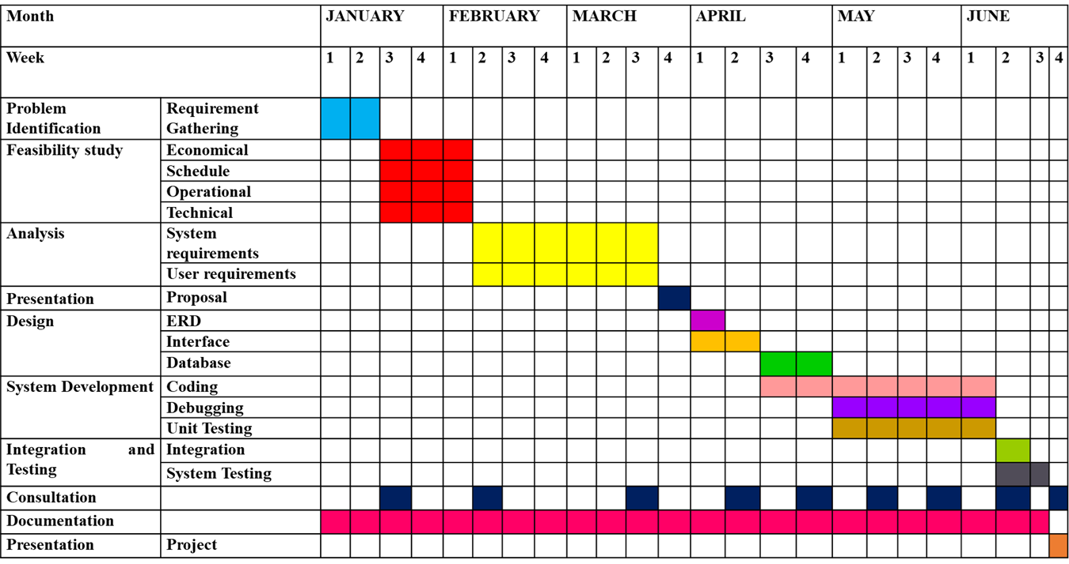

**Project Resources**



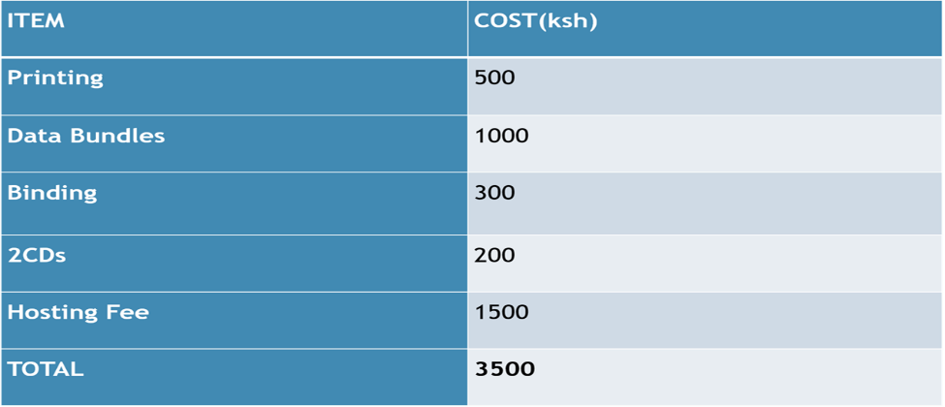

**Chapter Summary**

In this chapter, we explore the key aspects of scheduling, budgeting, and allocating resources for the development and implementation of Amber Villa Hotel management system. We dive into the following points:

* Scheduling: We discuss the importance of creating a realistic timeline for the project. By breaking down tasks, setting milestones, and assigning deadlines, we ensure that the project progresses smoothly and stays on track.
* Budgeting: We emphasize the need to estimate and manage costs associated with the system's development and maintenance. This includes considering expenses such as software licenses, hardware, staffing, training, and ongoing maintenance. Effective budgeting ensures that the project remains within financial constraints.
* Resources: We explore the process of assembling the required resources aimed at implementing the research project at hand.

**5.0 CHAPTER 5: SYSTEM DESIGN AND DEVELOPMENT**

This section describes the tools and technologies used.

**Sample codes and forms**

**6.0 SYSTEM TESTING AND IMPLEMENTATION**

Testing was done after the system was put in place. This was done in two ways namely Unit Testing and integration testing.

* **Test plan**

The Software Test Plan (STP) is designed to prescribe the scope, approach, resources, and schedule of all testing activities. The plan will identify items to be tested, the features to be tested, the types of testing to be performed, the personnel responsible for testing, the resources and schedule required to complete testing. The purpose of the software test plan is such as:

* To achieve the correct code and ensure all Functional and Design Requirements are implemented as specified in the documentation.
* To provide a procedure for Unit and System Testing.
* To identify the test methods for Unit and System Testing.
* **Process of Test Plan**
* Identify the requirements to be tested. All test cases shall be derived using the current design specification.
* Identify particular test to use to test each module.
* Identify the expected results for each test.
* Perform the test.
* Document the test data, test cases used during the testing process.

The following explain the ways in which testing is done.

* **Unit Testing**

Unit testing was carried out on individual modules of the system to ensure that they are fully functional units. This was done by examining each unit, for example the Underwriter’s page. It was checked to ensure that it functions as required and that it adds Customers data and other details and also ensured that this data is sent to the database. The success of each individual unit gave the go ahead to carryout integration testing. All identified errors were dealt with.

* **System Validation**
* **System Implementation**

**Bibliography**

• Kithinji, S., & Mbiti, I. M. (2020). *Adoption of technology in the hospitality industry: A case study of Kenyan hotels*. *Journal of Tourism and Hospitality Research, 15*(3), 45-60.

• Njenga, C. (2021). *The role of cloud-based property management systems in Kenyan hotels*. *International Journal of Hospitality Management, 37*(2), 112-125.

• Mwaura, P. (2019). *Impact of digital transformation on the hospitality industry in Kenya*. *African Journal of Business and Management, 11*(4), 89-101.

• Kamau, R., & Wanjiru, H. (2022). *Challenges and opportunities in hotel management systems: Insights from Kenya*. *Kenyan Journal of Hospitality and Tourism Studies, 8*(1), 22-38.

• Mwangi, J. (2023). *Sustainable practices in hotel management systems: A Kenyan perspective*. *Journal of Sustainable Tourism and Hospitality, 20*(1), 77-93.

• Chege, M., & Kiptoo, D. (2020). *The evolution of hotel management systems in Kenya: A historical overview*. *East African Journal of Business and Economics, 5*(2), 34-50.

• Ochieng, J. (2021). *Mobile technology and the future of hotel management in Kenya*. *Journal of Mobile Technology in Hospitality, 14*(2), 56-70.

• Otieno, L. (2022). *Customer relationship management systems in Kenyan hotels: Benefits and implementation challenges*. *Journal of Hotel and Business Management, 19*(3), 44-59.

• Gitau, F. (2023). *Artificial intelligence in hotel management systems: A review of applications in Kenya*. *Journal of AI and Hospitality, 6*(1), 20-35.

• Wambui, N. (2021). *Data security in hotel management systems: Protecting guest information in Kenyan hotels*. *International Journal of Information Security and Hospitality, 13*(4), 101-115.